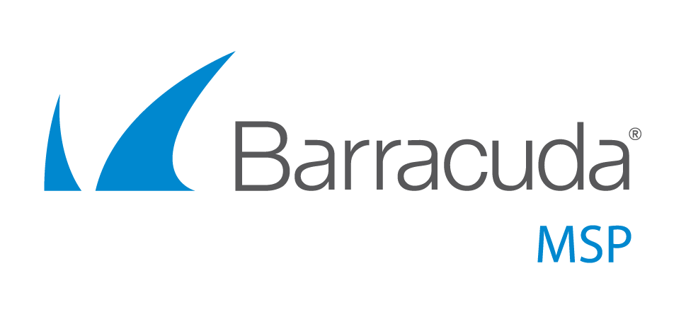


Your 12-Month MSP Marketing Plan
A Complete Template

This document is copyrighted © 2018 by Khera Communications, Inc., publishers of MoreBusiness.com. All Rights Reserved. You may modify this document to create a marketing plan for your own IT services company.

Also check out our #1 Amazon Bestseller, The IT Marketing Crash Course

Get professionally written content for your blog, email newsletter and security alerts. Visit https://www.morebusiness.com/shop/ to see our Content Library.

Contact: service@morebusiness.com

How to Use This Template

This IT marketing plan template includes month-by-month steps that will help you get new customers. To make it easier, we’ve created a series of free IT marketing webinars to guide you through many proven marketing strategies.

Register for IT Marketing Webinars →

This template is written as a monthly checklist. Lists allow you to review each item and check it off as you do it. You can edit the tasks in this plan to make it your own. For example, change “Month 1” to “April” and so on.

You will notice that once a specific task is defined, such as creating an ideal client profile, we do not list out the detailed steps when you do that task again in future months. Just refer back to the earlier month in which you did the task.

You will also notice a theme: repetition. Marketing is not something you do once in a while. There is deliberate consistency in messaging and actions. You will see actions that you do one month fall into place in future months.

A Suggestion

Every company is different so you should tweak this plan according the time you can commit. Whatever you do, don’t start and stop. Marketing done in fits and starts doesn’t work. That just wastes your time and energy – and money.

If you are serious about growing your company, dive in! A world of treasures awaits you. Good luck with your business!

Marketing Made Easy

MoreBusiness.com’s Content Library can make your marketing much easier than doing it all on your own. It will help you attract new leads, boost referrals and close more business. Several options to fit your budget:

- MSP Website Content Kit – pre-written SEO-friendly pages for your IT website, $399 or $299 using discount code website100
- MoreBusiness.com - access to our huge library of IT articles that you can edit, only $59 each or subscribe for heavy discounts

Month 1

- First half
  - Make a plan (or just edit this one), pick your team or sources of pre-written material (like MoreBusiness.com) to help with your marketing content, newsletter, blog, slide decks
  - Create an “ideal client” profile, your buyer persona:
- Organization size
- Job title and role within the organization
- Who has budget authority
- Key problems they face and how your solutions saves time, money and relieves headaches
- Roles of influencers (e.g., internal IT, accountants)
- Buying cycles
- Professional associations they join
- Conferences they attend
- Publications they read
  - Set up a MailChimp account (free for up to 2000 contacts) to send an email newsletter automatically from your blog posts (watch our webinars)
  - Subscribe to MoreBusiness.com’s marketing tips newsletter
- Second half
  - Interview 5-10 clients on why they picked you
    - “Hi John, this is ____ from ABC IT Solutions. We’re taking a quick survey of our customers and I was wondering if you had 3 minutes to spare – I’ve got some really simple questions.”
    - When you selected us for IT services…
      - Who else was involved in the decision process?
      - What factors were important in your evaluation?
      - Why did you pick us over others?
      - Where did you find out about us?
      - What associations do you belong to?
      - Which conferences do you never miss?
  - Ask each if they know anyone else who could use your IT services
    - Just curious, would you know other companies that could benefit from our IT services?
      - … maybe other people in <association name>?
      - … or your accountant/lawyer?
  - Identify organizations your clients belong to
  - Attend 1-2 networking events
  - Review/redo web site with educational marketing content (use pre-written pages from MSP Website Content Kit, 7000 words ready to copy/paste)

Month 2

- First half
  - Review your buyer persona for “client pain points”
  - Write headlines for 6 articles that would help a client
  - Write the articles or have them written (or license them from MoreBusiness.com)
  - Send 3 articles in a newsletter, post to blog
- Second half
  - Attend 2 networking events
  - Create a 25-slide presentation on one of these topics (about 30-40 minutes, maybe longer with questions from the audience):
    - How to Protect Your Business From Ransomware Attacks
    - The Most Overlooked IT Security Holes That Hackers Exploit
  - Record a video using the slide decks you created
    - Create a YouTube channel
    - Post the videos on YouTube
    - Mention the videos in your social media accounts

Month 3

- First half
  - Send next newsletter, post remaining 3 articles to blog
  - Attend 2 events, register for 2 next month
  - Continue interview/referral calls to existing customers
  - Identify partnership opportunities
- Second half
  - Identify headlines for next set of 6 articles, write content or acquire it from MoreBusiness.com
  - Contact 5 organizations that your clients belong to and offer to host a webinar, seminar or lunch-and-learn
  - Share article links on LinkedIn (do this every month)

Month 4

- First half
  - Send next newsletter, post 3 articles to blog
  - Attend 2 events, register for 1 for next month
  - Draft a guide/white paper based on first seminar topic
  - Send press release to promote your seminar next month

- Second half
  - View email analytics to see who is interested in what
  - Contact those who clicked on articles to start a dialog
  - Develop your next webinar/seminar topic:
    - The Most Common Ways Hackers Get Into Your Systems
    - Understanding the True Cost of Your IT Management Options
  - Record a video using the slides and post to your YouTube channel

Month 5

- First half
  - Present first seminar at association meeting; give guide
  - Send next newsletter, post 3 articles to blog
  - Print & mail guide to warmest prospects
  - Attend 1 event, register for 2 for next month
- Second half
  - View email analytics to see who is interested in what
  - Contact those who clicked on articles to start a dialog
  - Identify headlines for next set of 6 articles, write content or acquire it from MoreBusiness.com
  - Setup next association seminar

Month 6

- First half
  - Assemble a guide based on prior articles that are similar
  - Send next newsletter, post 3 articles to blog
  - Attend 2 events, register for 2 for next month
  - Send press release to promote your seminar next month
- Second half
  - View email analytics; make contact
  - Identify possible trade shows/conferences to exhibit at
  - Develop your next webinar/seminar topic:
    - The Hidden Dangers of Moving Your Data to the Cloud (and How to Resolve Them)
    - How to Protect Your Business From Phishing Attacks
  - Record a video using the slides and post to your YouTube channel

Month 7

- First half
  - Send next newsletter, post 3 articles to blog
  - Attend 2 events, register for 2 for next month
  - Print & mail newest guide to warmest prospects
  - Present seminar at next association event
- Second half
  - Call newest clients to ask buyer persona questions
  - Identify headlines for next set of 6 articles, write content or acquire it from MoreBusiness.com
  - View email analytics; make contact
  - Setup next association seminar event

Month 8

- First half
  - Send next newsletter, post 3 articles to blog
  - Attend 2 events, register for 2 for next month
  - Draft a guide based on newest seminar topic
  - Send press release to promote next month’s seminar
- Second half
  - View email analytics to see who is interested in what
  - Contact those who clicked on articles to start a dialog
  - Post guide(s) to web site behind form; advertise link
  - Develop next seminar
    - 10 Ways to Keep Your Company Data Secure

Month 9

- First half
  - Present next seminar at association meeting; give guide
  - Send next newsletter, post 3 articles to blog
  - Print & mail guide to warmest prospects
  - Attend 2 events, register for 2 for next month
  - Identify partnership opportunities

- Second half
  - View email analytics to see who is interested in what
  - Contact those who clicked on articles to start a dialog
  - Identify headlines for next set of 6 articles, write content or acquire it from MoreBusiness.com
  - Setup next association seminar; promote next month’s

Month 10

- First half
  - Send next newsletter, post 3 articles to blog
  - Attend 2 events, register for 2-3 for next month
  - Print & mail newest guide to warmest prospects
  - Identify possible trade shows/conferences to exhibit at
  - Call newest clients with buyer persona questions
- Second half
  - Present seminar at next association event
  - View email analytics; make contact
  - Develop/repurpose your next seminar topic

Month 11

- First half
  - Assemble a guide based on prior articles that similar
  - Send next newsletter, post 3 articles to blog
  - Attend 2 events, register for 2-3 for next month
- Second half
  - View email analytics; make contact
  - Identify headlines for next set of 6 articles, write content or acquire it from MoreBusiness.com

Month 12

- First half
  - Send next newsletter, post 3 articles to blog
  - Attend 2 events, register for 2 for next month

- Second half
  - View email analytics; make contact
  - Develop/repurpose next seminar topic
  - Review marketing plan
  - Identify steps and budget for next 12 months

Notes:

- Attending networking events can be done any time during the month. The task is listed in the first or second half just for ease of documentation, not for when your networking events will actually occur.
- You should publicize your blog posts to LinkedIn each time you post something. We’ve only listed it here once, but do it each month.
- One way to send press releases is through online wire services like e-Releases, which can get your announcements placed in dozens (even hundreds) of publications.
- For trade shows/conferences, you will have to put those into your plan. We haven’t listed them in any particular months because they would vary based on where you are and who you target.
- For promoting your guides, you can advertise via links on association pages, LinkedIn, or even try Facebook. The key is to give away a useful piece of content that people would be willing to exchange their contact information for. Attend our MSP marketing webinars to learn ways that increase qualified leads from your website.
- Printing and mailing guides is not required for smaller budgets.

Get IT Content and Tools to Grow Your IT Business

Your clients use you because you’re an IT expert.
IT companies use us because we’re IT marketing experts.
Download pre-written marketing content that you can use immediately:

- MSP Website Content Kit
- Educational IT Articles

